Module #: | Module 4
Module Title: | Generating an individual progress report using the finer measures of TMOA (NWRM) as the progress and achievement marker.
Presenter  Name:  Iwi:  Title: | Chrissy Ward  Ngāti Hineira, Te Uri Taniwha, Ngāpuhi  Kia Ata Mai Educational Trust Kaimahi
Slide 1  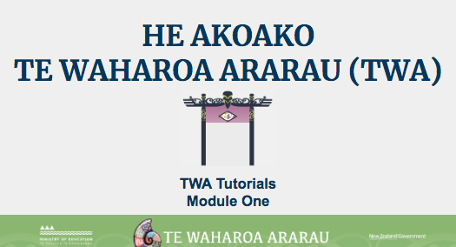 | Kei aku rangatira huri noa i Aotearoa e mātaki mai ana, tēnā tātou katoa.  Nau mai ki tēnei akoako poto e pā ana ki te whakahoutanga o Te Waharoa Ararau.
Slide 2  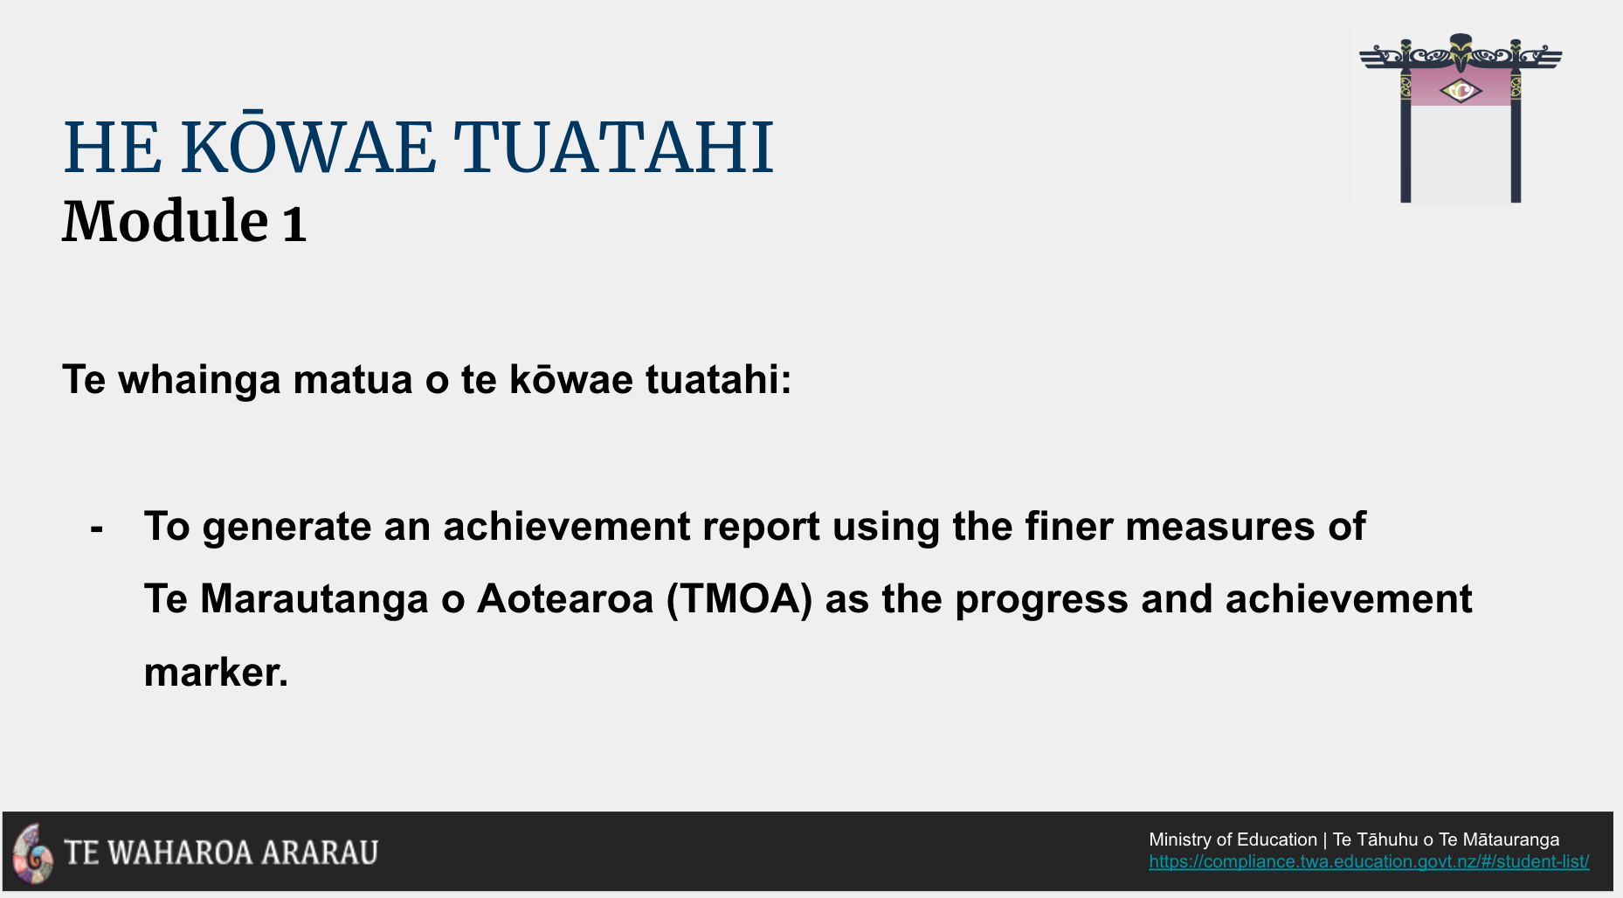 | In this tutorial, we’re going to show you how to generate an individual report using the finer measures of TMOA (NWRM) as the progress and achievement marker.
Slide 3  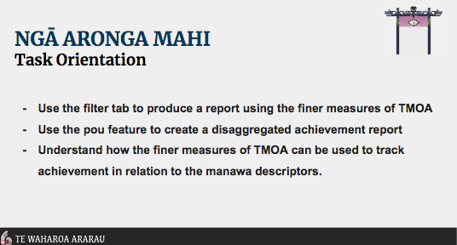 | By the end of this tutorial you should be able to independently:  - Use the ‘Ngā Tātaringa’ filter tab to produce an individual report using the finer measures of TMOA (NWRM) as the progress and achievement marker.  Let’s take a closer look at how this is done through the Pūrongo Tab.
LIVE to Purongo Tab  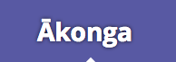 | The default landing view in the Pūrongo Tab is the Kura sub-tab.  Click on the Ākonga sub-tab to open settings to generate individual ākonga progress and achievement reports.
NWRM Progress Report  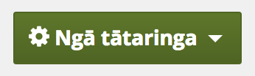  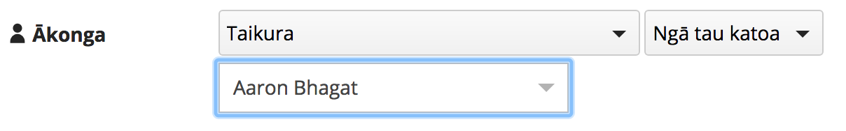  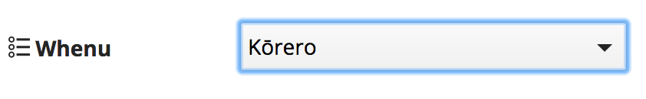  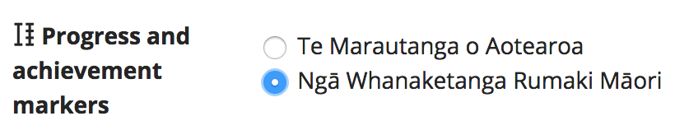  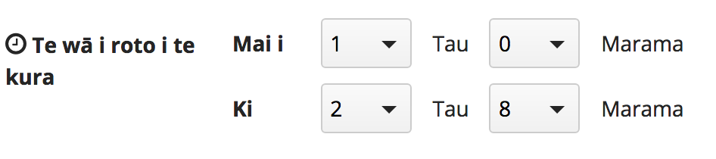  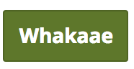 | Click the Ngā Tātaringa filter tab to select he group and ākonga you want to make a progress report for.  For this example we are selecting the Taikura Group and Aaron Bhagat as our ākonga.  Use the dropdown arrow to select the whenu you wish to generate a report for.  NOTE: The default whenu is Kōrero.  Select NWRM to generate a progress report using the finer measure of TMOA. You will be familiar with these from the previous version of TWA.  The last filter option in this window is,  Te wā i roto i te kura - remember to select the timeframe you want to view progress in.  Don’t forget to click the ‘Whakaae’ button!  The graph generated from these filters shows all OTJs entered in relation to the finer measures of TMOA (NWRM) in the description of the Manawa Levels.  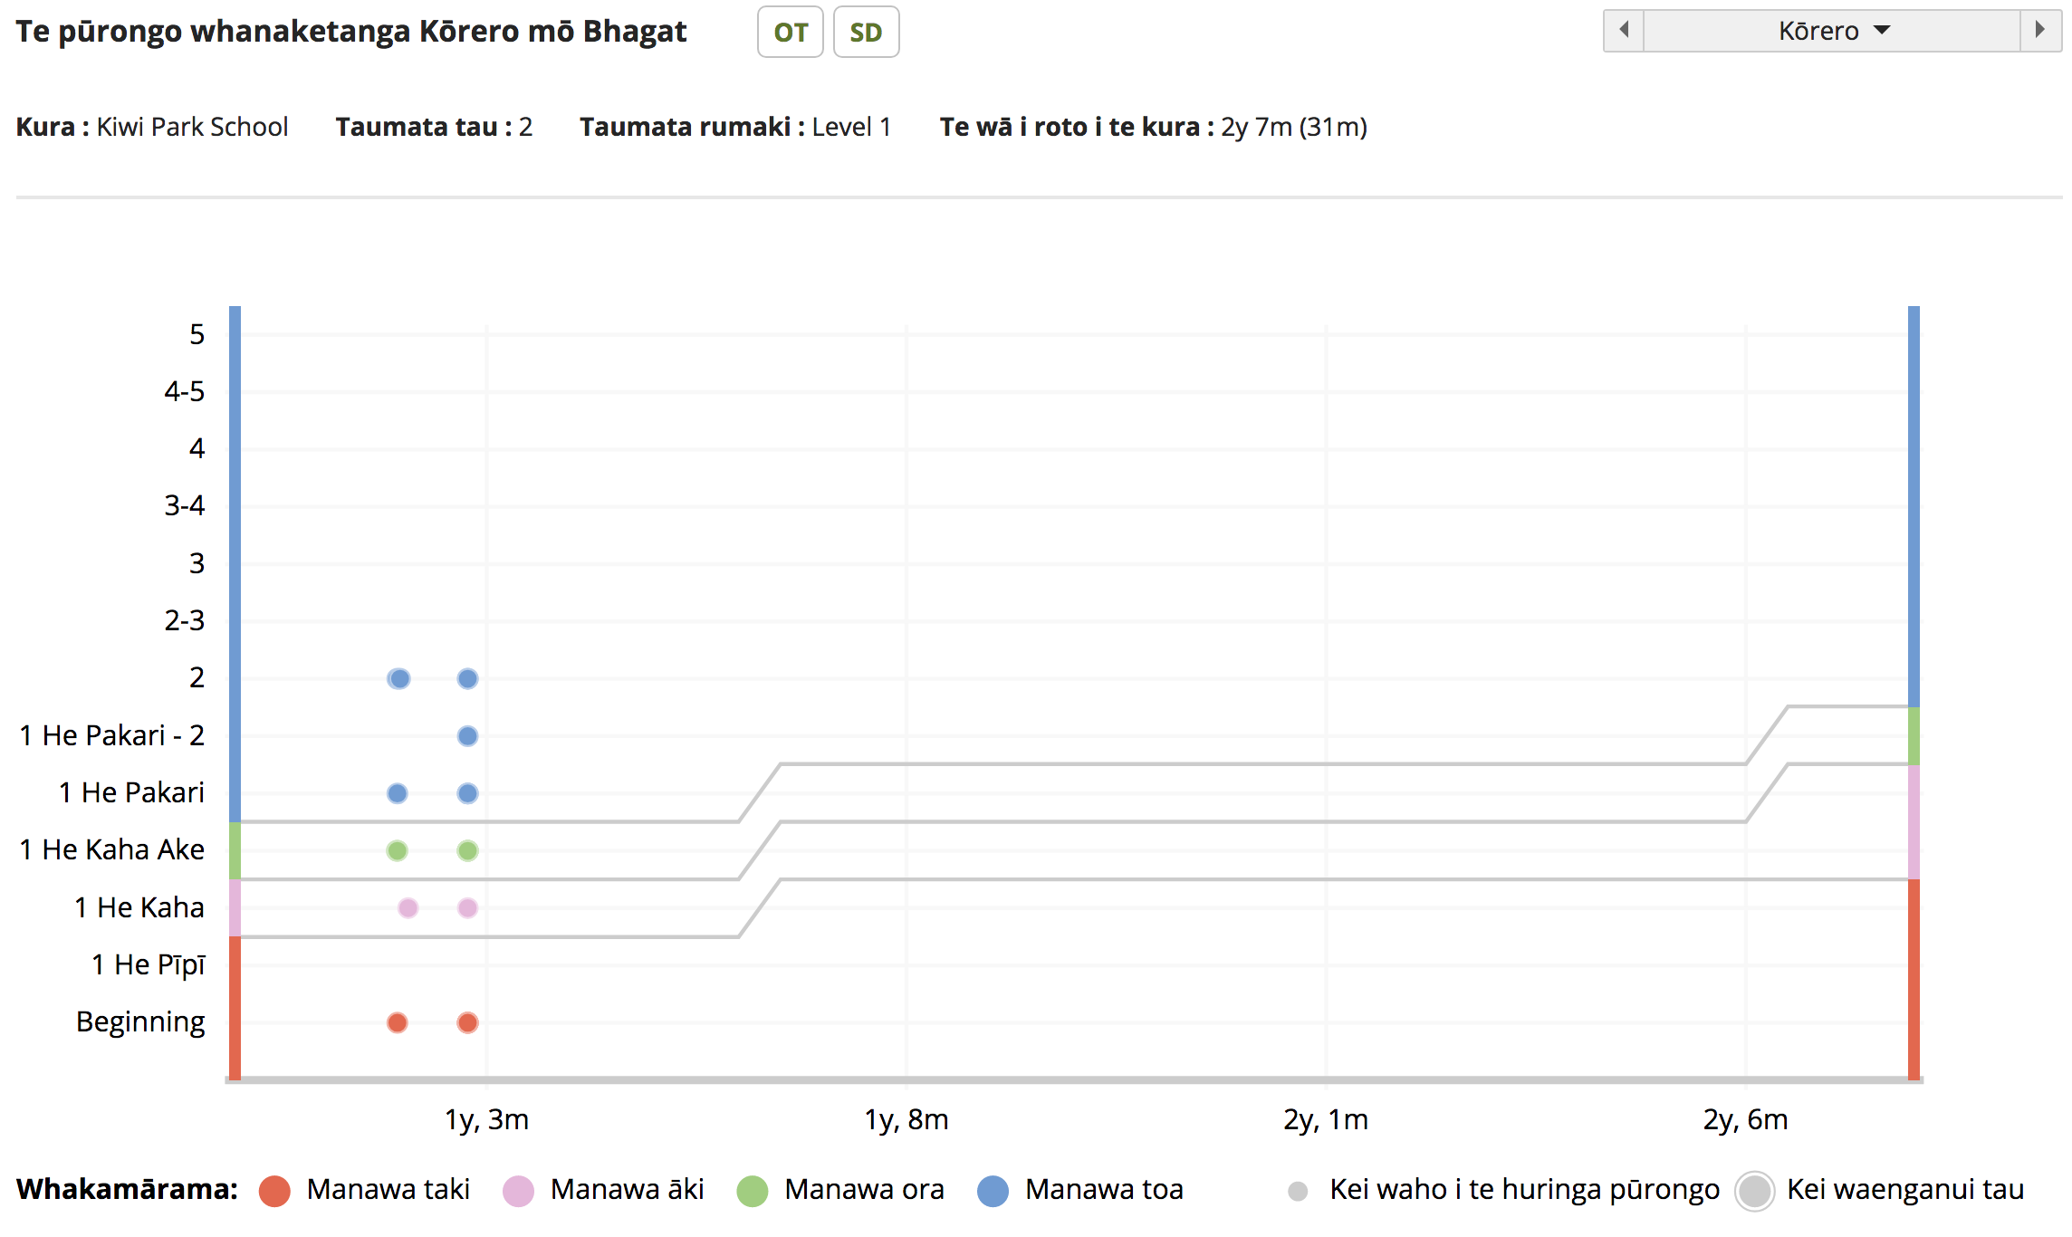  Below the graph, there is also a chronological record of OTJs entered.  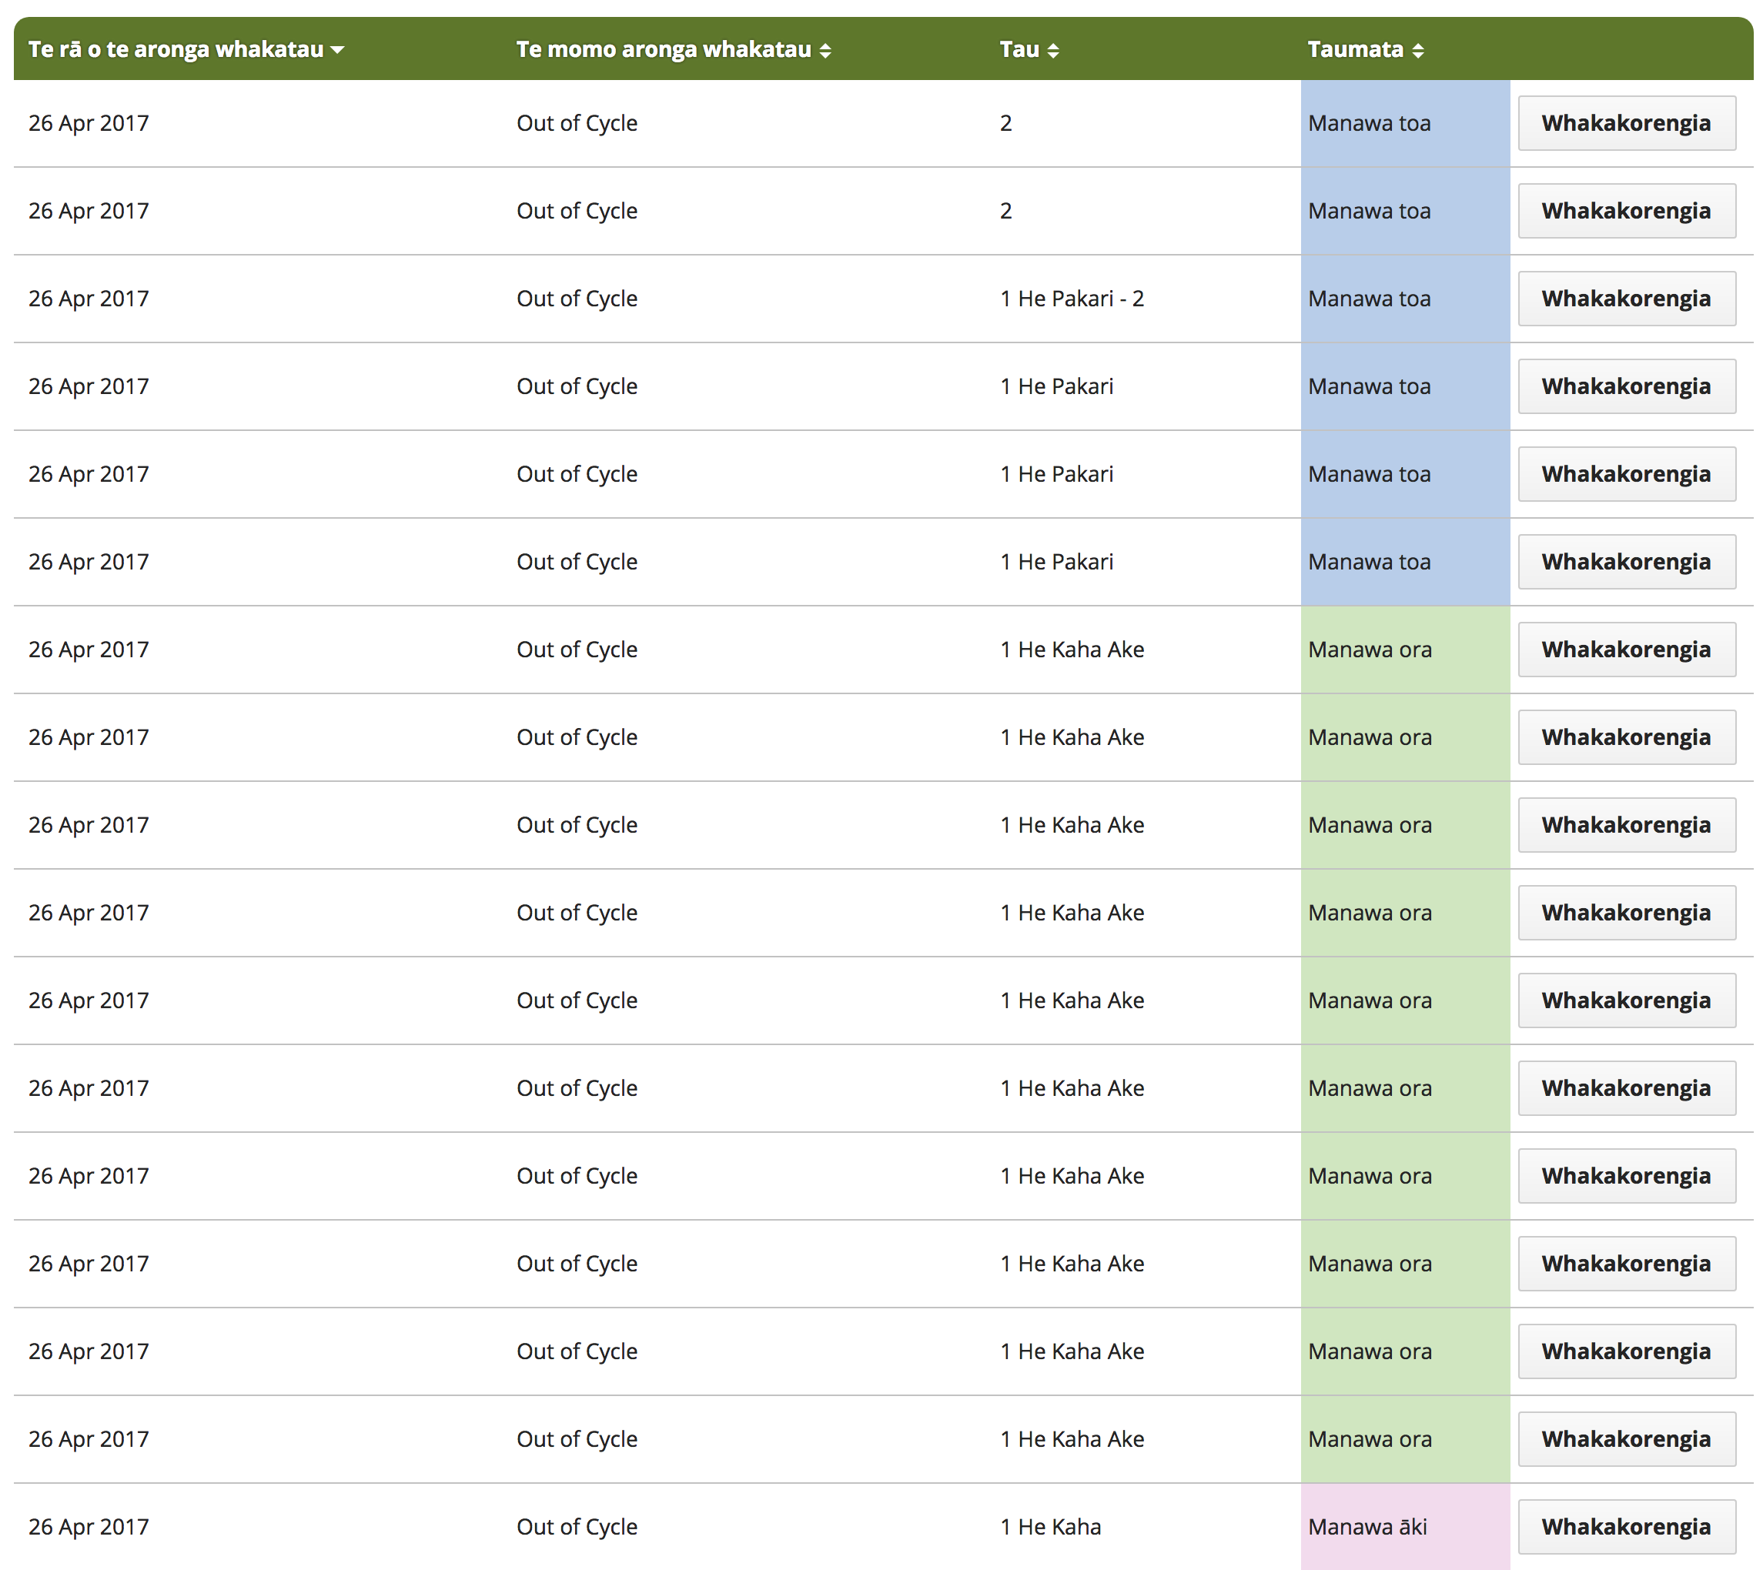
Slide 5  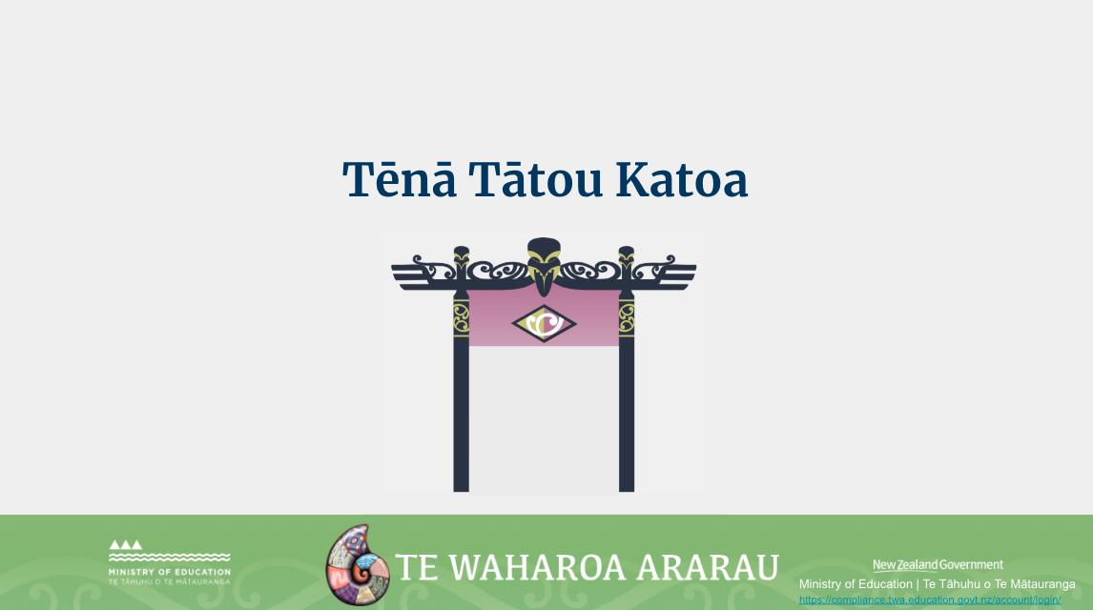 | Ko te manako ia, kua whai hua koutou i tēnei akoako poto me ngā kai o roto.  Nei rā anō te mihi manahau ki a koutou katoa.

